Disability Inclusion through Mutual Learning Project

Meeting minute

Participants: Prochesta & DHRC-Staff members
Date: 21 July 2022.

Based on the needs and demands of the program, this meeting of the NOREC Round 3 project was held where the following issues were discussed with the participation of all NOREC and DHRC-Nepal staff members and Prochesta management staffs. The basic agenda of the meeting were:

Agenda:
- DHRC-Nepal staff recruitment;
- Activity progress;
- COVID updates;
- Financial progress up to June 2022;
- New project proposal;
- Concept note for Round-3;
- Presentation for the meeting with Ms Marit;
- Cultural context of two countries; and
- AoB.
- Next meeting
- Training

Discussion and decision are as follows:

- Staff recruitment:

Currently, Jagadish Prasad Adhikari (Advisory role), Chanda Shrestha and Sashi Shrestha (Programmatic role) and Ramila Gautam (finance management role) are engaging under NOREC Project. This has been continuing without any further changes.

- Activity progress

Prochesta has completed and also continuing the following activities:
- PSA on radio;
- Conducting meeting with the disables;
- Continuation of sharing disability issues among other staffs members;
- Continue follow up of the disable students of the schools;
- COVID’19 progress and culture exchange are sharing with DHRC-Nepal;
- Meeting with youth forum members etc.

Update from DHRC-Nepal

- Teachers Training on Inclusive Education along with replication training.
No. of school participated: 11 schools
No. of participants – 31 (2 teachers from each school, Representatives from Education Department of Local Government and Resource Person and other supportive team)
Trainer – Dr. Birendra Raj Pokharel
Venue – Khagendra Nawa Jivan School
Date- 1 and 2 July, 2022
- Advocacy for IE and disabilities rights through radio program and magazine
Link:https://www.youtube.com/watch?v=S8s6q2uSZIY
- Regular Exchange and sharing between Prochesta Bangladesh and DHRC Nepal about information on situation and covid etc.
- Concept development and share with Prochesta - KIOS, USAID, TLMN, GOAD
- Interaction with children, helping teacher to identify children with disability and list prepared for education material distribution.
- Advocacy for IE through television program.
https://www.youtube.com/watch?v=MZ9WR_vahPE
https://www.youtube.com/watch?v=6G7ATtciMuk&t=539s

- COVID updates:

- Bangladesh update up to 19 July 2022:

Bangladesh reports 8 deaths, 879 Covid cases in 24 hrs

The number of detected novel coronavirus cases in the country, according to the government, rose to 1,998,291 on Tuesday as 879 more cases were reported, after testing 9,099 samples, including rapid antigen tests, in the last 24 hours. The rate of detection in the last 24 hours until 8:00am was 9.66 per cent while the overall rate of detection of infected cases in Bangladesh as of Tuesday stands at 13.76 per cent. On Monday, the number of detected novel coronavirus cases in the country, was 1072 more cases were reported, after testing 10,902 samples, including rapid antigen tests, in the last 24 hours.
The trend of infection rate of novel coronavirus is reducing day by day but the fatal rate is still alarming.
During the period, eight patients died of Covid-19. As of Tuesday, the death toll stands at 29,249, according to the press release of the Directorate General of Health Services (DGHS). On Monday, seven patients died of Covid-19.
The health directorate Tuesday said a total of 1,693 people recovered from the highly infectious disease in the last 24 hours, taking the total recovery to 1,928,650.
Bangladesh detected its first coronavirus patient on 8 March in 2020 and recorded its first death of the disease on 18 March that year.

- Updates from Nepal up to 19 July 2022:

In Nepal new variant infection cases are rising every day. In 24 hours the infected cases are 386. Yesterday there was also a fatal case. Here is more detail info on COVID in Nepal.
Covid is spreading at an alarming rate in Nepal as the country recorded its first death in 73 days recently. The positivity rate, stood at 0.64 per cent on June 15, increased 10 folds as the positivity rate was 6.15 per cent on July 15. With this, many are wondering if the fourth wave of Covid-19 is about to hit Nepal.

According to the Ministry of Health and Population, new variants of the coronavirus–BA.5 and BA.2.75–have have been found in Nepal. Both of these variants are high contagious.

A week ago, the National Public Health Laboratory found two cases of BA.5 out of the 32 it tested. Four other cases of BA.5 were found when Dhulikhel Hospital tested 16 positive cases. This is a concern for public health experts as BA.5 is the most contagious coronavirus variant to date. And, since it is already spreading within communities, they argue that it might spread rapidly in the coming few weeks.

The Epidemiology and Disease Control Division (EDCD) says a lot of people coming from India to Nepal are testing positive for coronavirus, suggesting most of these cases might have been infected by the new variants.

“Around 35 per cent of coronavirus cases are from the border point between Nepal and India,” says EDCD Director Dr Chuman Lal Das. “The fourth wave is upon us. The new variant has already spread.”

Public Health experts say the country needed to take this seriously. Dr Anup Subedee, an infectious disease expert, also says the virus has already spread within the community.

“One and a half months ago, the positive rate was 0.2 per cent, but that has reached 6.15 per cent. This is scary and we will see its result in the coming two weeks,” says Subedee.

Dr. Sher Bahadur Pun, the chief of the Clinical Research Unit at Sukraraj Tropical and Infectious Disease Hospital in Teku, also says the new variants, in particular, BA.5, had already spread in the community.

Public health experts say that the new variant is affecting even those who were vaccinated. According to recent research, the infection rate of Omicron was 12. The infection rate for BA.5 is 18. This means one person with BA.5 can infect up to 18 people.

“This will affect people who are vaccinated and those who contracted the virus,” says Pun. “We fear the number of cases will rise exponentially.”

Subedee agrees with Pun and says even those who had taken the booster dose will be affected.

With a rise in Covid cases due to the new variants, the number of people being admitted to the hospitals is increasing. According to the Health Ministry, of the 1,439 active cases in the country, 69 people have been admitted to the hospitals; 18 of them are in the ICU and one is on a ventilator.

A month ago, TU Teaching Hospital had zero cases; on Friday, it had three. The hospital’s focal person Dr Niraj Bam says people with Covid are being admitted to the hospitals.

“The number of people coming to test themselves has increased in the past two weeks along with those being admitted,” says Bam. “We’ve been giving them oxygen support to help with breathing.”

Doctors say the number is expected to rise soon as a lot of people who have Covid-like symptoms have not tested themselves along with those who are asymptomatic.

Patan Hospital’s Dr Ravi Shakya says that the spread of new variants will mostly affect those with chronic diseases who have poor immunity.

“We, once again, have a challenge on our hands,” says Shakya.

Other public health experts feel the number of people being admitted to hospitals will increase in the coming two weeks.

Time to follow public health protocols

Former director at the Sukraraj Tropical and Infectious Disease Hospital, Dr Anup Bastola says people should stop being careless and start following public health protocols that the government put in place during the first three waves.

“People take Covid very lightly. But, now, with the new variants, it’s time they took it seriously. We need to mask up and maintain distance. The government should start raising awareness,” says Bastola

- Financial progress up to June 2022:

Both the countries got the 1st and 2nd installments of the Round-3 budgets. And we’re continuing the expenses on the project activities. The fund flow didn’t interrupt the project interventions. Both the countries decided to present the expense status up to June 2022 in the meeting with Ms Marit. Hence, DHRC-Nepal is requested to submit financial report to Prochesta up to June 2022 within 25 July 2022.
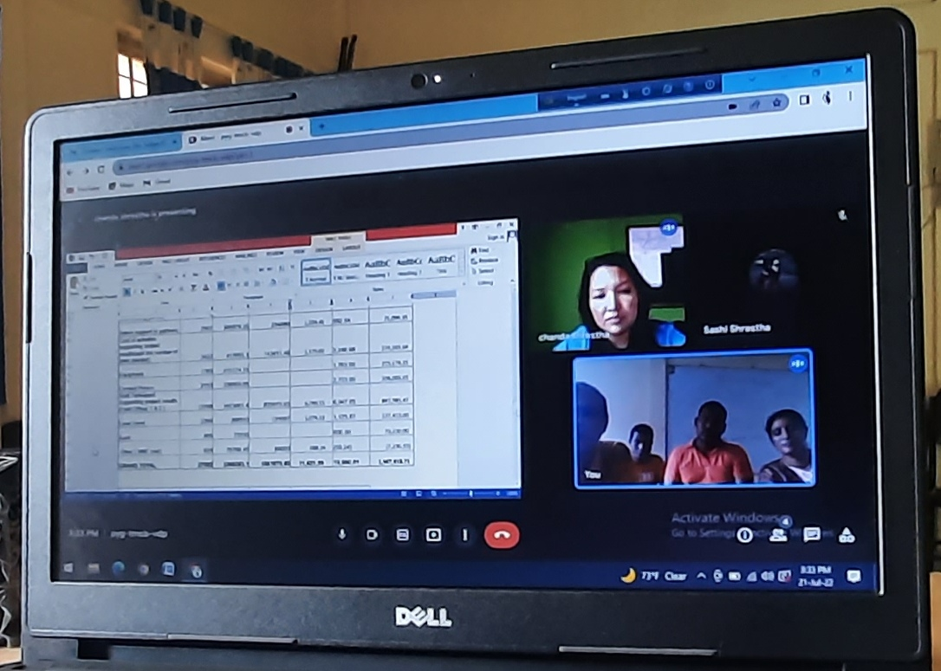
Nepal Disabled Human Rights Center
Budget Vs Expenditure of Norec Project
1 February 2022 to 15 July
PARTICIPANT EXPENSES | Budgeted amount |  | Expenditure Till 15 July |  | Remaining Balances
 | in USD | in NRP | in NRP | in USD | in USD | In NRP
PROJECT EXPENSES
ADMINISTRATIVE AND ACTIVITIES |  |  |  |  | -
Project coordinator, coordinating partner | 0
Admin support to partners | 2507 | 305979.35 | 234880 | 1,924.46 | 582.54 | 71,099.35
Cost of activities supporting project results(add the number of rows needed) | 3422 | 417655.1 | 143411.46 | 1,175.02 | 2,246.98 | 274,243.64
Equipment | 1763 | 215174.15 |  | - | 1,763.00 | 215,174.15
Contact Person | 2753 | 336003.65 |  | - | 2,753.00 | 336,003.65
Staff Participant Supporting project results (Field Officer 1 & 2 ) | 13708 | 1673061.4 | 825075.93 | 6,760.15 | 6,947.85 | 847,985.47
Local travel | 2200 | 268510 | 131097 | 1,074.13 | 1,125.87 | 137,413.00
Audit | 600 | 73230 |  | - | 600.00 | 73,230.00
Other ( M&E cost) | 629 | 76769.45 | 84000 | 688.24 | (59.24) | (7,230.55)
GRAND TOTAL | 27582 | 3366383.1 | 1561875.85 | 11,621.99 | 15,960.01 | 1,947,918.71
Installment received | exchange rate | approves | USD Doller | Amount in NPR | bank charge
1st Installment received on 18/02/2022 | 119.45 | 15000 | 14,988.00 | 1,790,316.60 | 12.00
2nd Installment received on 19/05/2022 | 124.65 | 8000.00 | 7,988.00 | 995,704.20 | 12.00
Total Amount | 244.1 |  | 22,976.00 | 2,786,020.80 | 24.00
Average rate | 122.05

- New project proposal:

Both the organization are reviewing the document of new project proposal submission and thinking about the issue of the project. The probable areas could be health and nutrition; rights and entitlements; life skill development of Youth and Adolescents; etc. Prochesta will sit among the senior management about the new project and its partnerships modality within this month and try to submit proposal within 15 August 2022.
DHRC Nepal shared about the few challenges on physical exchange for the new application, firstly due to COVID’19 pandemic and secondly obtaining working visa for the foreigner is quite tedious and we concluded that we’ll share the challenges to Ms. Marit who might suggest us way forward.

- Concept note for Round-3:

Prochesta already provided two concept notes of Round-3. DHRC-Nepal is requested to provide the number of concept notes within 30 July 2022. During the activity presentation we’ll able to highlights our achievements with skill and confidence.

During the period of February to July 2022, NOREC participants from DHRC Nepal wrote couple of concept notes. Concept notes to USAID turn on to be positive and DHRC Nepal is still waiting for the response from KIOS. DHRC agreed to share those two concept notes along with TLMN and GOAD. Concept notes are shared with Prochesta.

- Presentation for the meeting with Ms Marit:

Ms Chanda had a plan to submit the activity and financial progress within 22 July 2022 and she is in track to do that. Mr. Suruj has started working for the presentation document that to be presentation during the meeting with Ms Marit combining the achievements of DHREC-Nepal also. There is very less time compared to last year for the meeting. We need to highlights the partnerships as well as project achievements; team efforts and strengths towards project goal; sustainability of the achievements; voice and rights of the disables etc. very carefully so that we can claim for new project confidently.

Please find attached presentation including both programmatic and financial updates from DHRC Nepal.

- Cultural context of two countries:

Muslims in Bangladesh and living within the globe celebrates two greatest festivals named Eid-Ul-Fitre and Eid-Ul-Adha. Both the cases government of Bangladesh provides holidays. In NGO sectors it is up to 7-8 days considering the country peoples involvements with the festivals. First one is celebrated just after fasting of one month, the holy Ramadan. During the Ramadan month government and NGOs reduces office hour for all employees (all casts) so that the Muslims can offer the prayers at day and night (special prayers on for Ramadan month) nicely and also continue office.

For the 2nd festival, the holy Eid-Ul-Adha Muslims are very busy for the sacrificing to God by slaughtering animals like sheep or goat or cows/bulls, buffalo, camel etc depending on the financial capacity. For the poor and incapables it is not needed to sacrifice the animals. Normally, at rural level and also at mini town level it is done in a common place of a community school/college fields, markets, courtyards, large open place where all can gather and perform the slaughtering of the animals. The meets are divided in three portions one portion is for own consumption, 2nd one for the relatives and 3rd part for the community. All the 3rd portion of all the people of a community gathered in one place and divided among the all members of the community irrespective poor, rich, destitute etc. So that everyone of the community can eat the meats.

In the main capital city, at Dhaka People doesn’t gather in a common place rather they perform the slaughtering the animal at their door step or road side or their convenient place. At this case they distribute the meats by their own account. Government has to take special initiatives to clean the rubbish and make capital city like before. It is really huge tasks and need to perform with special manpower. This year government was very successful to dirt free the city timely.

Normally we had to depend on the neighboring countries like India (mostly), Myanmar and Nepal for the importing animals through legal or illegal way. India is now very strict to control the border and we’re not getting the animals like before. Good news is that Bangladesh is now surplus of producing the animals for the Eid-Ul-Adha period and also for the year around to mitigate supply of meat.

A lot of livestock industries have grown up to supply the animals for the country and also for the export. At the rural areas individual family is fattening the cows and goats and find it as a sources of earning for whole the year. Technology, experts and feeds are also available for the grown up, treatment and medicine support even at rural areas those are expanding day by day.

Eid al-Adha marks the culmination of the hajj (pilgrimage) rites at Minā, Saudi Arabia, near Mecca, but is celebrated by Muslims throughout the world.

The link is here for more about it. https://www.officeholidays.com/holidays/eid-al-adha

Cultural sharing from Nepal

Shrawan also known as Saaun/sawan is the fourth month in the Bikram Sambat, the official Nepali calendar. This month coincides with July 17 to August 16 of the Western calendar and is 32 days long. Basically all women including married and unmarried take fasting every Monday worship lord shiva. A married woman worship and take fasting for a long life of husband and to those girl who is unmarried take fasting and worship to have a nice husband in future. During this time, special prayers will be offered to Lord Shiva and his family in temples across the country.

All women and girls are fascinated with green clothing, green bangles and print their palms with henna/mehendi. This year these women take this festival more importantly because five Mondays fall in this month.

- AoB.

- Next meeting: The next meeting will be held before the meeting with Ms Marit.
- Training: Prochesta will conduct training for DHRC-Nepal from August 2022.

Finally the meeting was concluded with a vote of thanks.
Minutes recorded by: Chanda Shrestha, Program Manager, DHRC Nepal and Md. Suruj Ali Sarkar, Director Program, Prochesta.

